Student Name: __________________
Class and Section __________________
Total Points (20 pts) __________________
Due: Feb 7, 2011 before the class

Project: Accessing and updating a Staff table (Servlets)

CSCI 5520 Rapid Java Application Development
Armstrong Atlantic State University

Problem Description:

Write a Java servlet that views, inserts, and updates staff information stored in a database, as shown in the following figure. The view button displays a record with a specified ID. The Staff table is created as follows:
create table Staff (
id char(9) not null,
lastName varchar(15),
firstName varchar(15),
mi char(1),
address varchar(20),
city varchar(20),
state char(2),
telephone char(10),
email varchar(40),
primary key (id)
);

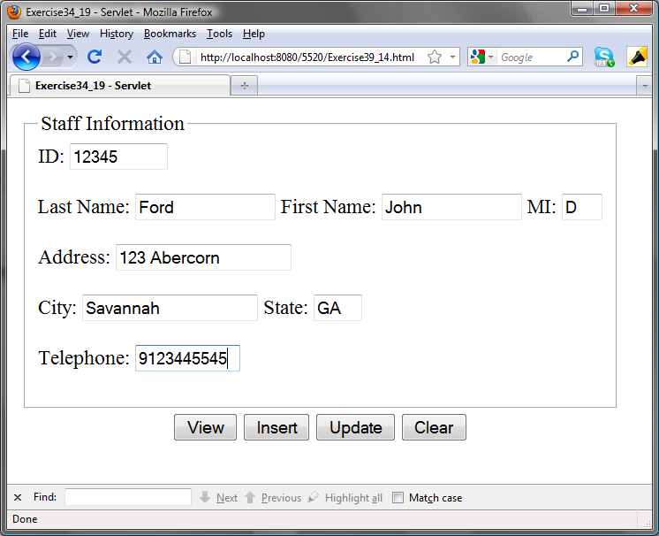

Source code: (Name your program Exercise37_14)

Screen shot:

What to submit?

- This document.
- Save/Compile and Submit to LiveLab (Make sure your program compiles! You must submit the program regardless whether it complete or incomplete, correct or incorrect)

2. Fill in self-evaluation:

- Can you display the form using HTML? _________
- Can you connect to the database? ______
- Is the View button implemented correctly? _______________
- Is the Insert button implemented correctly? ________
- Is the Update button implemented correctly? ________
- Is the Clear button implemented correctly? ________

Solution:

<!--
To change this template, choose Tools | Templates
and open the template in the editor.
-->

<!DOCTYPE HTML PUBLIC "-//W3C//DTD HTML 4.01 Transitional//EN">
<html>
<head>
<meta http-equiv="Content-Type" content="text/html; charset=UTF-8">
<title>Exercise34_19 - Servlet</title>
</head>
<body>
<table>
<tr>
<td>
<fieldset>
<legend>Staff Information</legend>
<form action="Exercise41_13" method="GET">
ID: <input type="text" name="ID" size="9"><br><br>
Last Name: <input type="text" name="lastName" size="15">
First Name: <input type="text" name="firstName" size="15">
MI: <input type="text" name="mi" size="1"><br><br>
Address: <input type="text" name="address" size="20"><br><br>
City: <input type="text" name="city" size="20">
State: <input type="text" name="state" size="2"><br><br>
Telephone: <input type="text" name="telephone" size="10"><br>
</fieldset>
</td>
</tr>
<tr align="center">
<td>
<button type="submit" name="go" value="View">View</button>
<button type="submit" name="go" value="Insert">Insert</button>
<button type="submit" name="go" value="Update">Update</button>
<button type="submit" name="go" value="Clear">Clear</button>
</td>
</tr>
</form>
</table>
</body>
</html>

package chapter41;

import java.sql.*;
import java.io.IOException;
import java.io.PrintWriter;
import javax.servlet.ServletException;
import javax.servlet.http.HttpServlet;
import javax.servlet.http.HttpServletRequest;
import javax.servlet.http.HttpServletResponse;

public class Exercise41_13 extends HttpServlet {

private Connection connection;
private PreparedStatement preparedInsertStatement;
private PreparedStatement preparedViewStatement;
private PreparedStatement preparedUpdateStatement;
String IDValue = "";
String lastNameValue = "";
String firstNameValue = "";
String miValue = "";
String addressValue = "";
String cityValue = "";
String stateValue = "";
String telephoneValue = "";

/**
* Processes requests for both HTTP <code>GET</code> and <code>POST</code> methods.
* @param request servlet request
* @param response servlet response
* @throws ServletException if a servlet-specific error occurs
* @throws IOException if an I/O error occurs
*/
protected void processRequest(HttpServletRequest request, HttpServletResponse response)
throws ServletException, IOException {

response.setContentType("text/html;charset=UTF-8");
PrintWriter out = response.getWriter();

try {
//connect to database
initializeJDBC();

//show results
if (request.getParameter("go").equals("View")) {
if (request.getParameter("ID").isEmpty()) {
printForm(response);
} else {
try {
//SQL statement
String SQLView = "SELECT lastName, "
+ "firstName, mi, address, city, state, telephone "
+ "FROM Staff WHERE Staff.id = ? ";

//create prepared statement
preparedViewStatement = connection.prepareStatement(SQLView);
preparedViewStatement.setInt(1, Integer.parseInt(request.getParameter("ID")));
ResultSet rset = preparedViewStatement.executeQuery();

if (rset.next()) {
IDValue = request.getParameter("ID");
lastNameValue = rset.getString(1);
firstNameValue = rset.getString(2);
miValue = rset.getString(3);
addressValue = rset.getString(4);
cityValue = rset.getString(5);
stateValue = rset.getString(6);
telephoneValue = rset.getString(7);

//recreate html form with data returned from database
printForm(response);

} else {
out.println("ID not found. Use browser back button to return to form.");
}
} catch (SQLException ex) {
out.println(ex.getMessage());
}
}
} else if (request.getParameter("go").equals("Insert")) {
if (request.getParameter("ID").isEmpty()) {
printForm(response);
} else {
try {
//SQL Strings
String SQLInsert = "INSERT INTO Staff "
+ "(id, lastName, firstName, mi, "
+ "address, city, state, telephone) "
+ "VALUES (?, ?, ?, ?, ?, ?, ?, ?)";

IDValue = request.getParameter("ID");
lastNameValue = request.getParameter("lastName");
firstNameValue = request.getParameter("firstName");
miValue = request.getParameter("mi");
addressValue = request.getParameter("address");
cityValue = request.getParameter("city");
stateValue = request.getParameter("state");
telephoneValue = request.getParameter("telephone");

preparedInsertStatement = connection.prepareStatement(SQLInsert);
preparedInsertStatement.setInt(1, Integer.parseInt(request.getParameter("ID")));
preparedInsertStatement.setString(2, request.getParameter("lastName"));
preparedInsertStatement.setString(3, request.getParameter("firstName"));
preparedInsertStatement.setString(4, request.getParameter("mi"));
preparedInsertStatement.setString(5, request.getParameter("address"));
preparedInsertStatement.setString(6, request.getParameter("city"));
preparedInsertStatement.setString(7, request.getParameter("state"));
preparedInsertStatement.setString(8, request.getParameter("telephone"));
preparedInsertStatement.execute();

//recreate html form with data returned from database
printForm(response);
} catch (SQLException ex) {
out.println(ex.getMessage());

}
}
} else if (request.getParameter("go").equals("Update")) {
if (request.getParameter("ID").isEmpty()
|| request.getParameter("lastName").isEmpty()
|| request.getParameter("firstName").isEmpty()
|| request.getParameter("mi").isEmpty()
|| request.getParameter("address").isEmpty()
|| request.getParameter("city").isEmpty()
|| request.getParameter("state").isEmpty()
|| request.getParameter("telephone").isEmpty()) {
printForm(response);
} else {
try {
//SQL statement
String SQLUpdate = "UPDATE Staff SET "
+ "lastName = ?, firstName = ?,"
+ " mi = ?, address = ?, city = ?,"
+ " state = ?, telephone = ? "
+ "WHERE id = ?";

IDValue = request.getParameter("ID");
lastNameValue = request.getParameter("lastName");
firstNameValue = request.getParameter("firstName");
miValue = request.getParameter("mi");
addressValue = request.getParameter("address");
cityValue = request.getParameter("city");
stateValue = request.getParameter("state");
telephoneValue = request.getParameter("telephone");

//create prepared statement
preparedUpdateStatement = connection.prepareStatement(SQLUpdate);
preparedUpdateStatement.setString(1, request.getParameter("lastName"));
preparedUpdateStatement.setString(2, request.getParameter("firstName"));
preparedUpdateStatement.setString(3, request.getParameter("mi"));
preparedUpdateStatement.setString(4, request.getParameter("address"));
preparedUpdateStatement.setString(5, request.getParameter("city"));
preparedUpdateStatement.setString(6, request.getParameter("state"));
preparedUpdateStatement.setString(7, request.getParameter("telephone"));
preparedUpdateStatement.setInt(8, Integer.parseInt(request.getParameter("ID").toString()));
preparedUpdateStatement.executeUpdate();

//recreate html form with data returned from database
printForm(response);
} catch (SQLException ex) {
out.println("<html><body>");
out.println(ex.getMessage());
out.println("</body></html>");
}
}
} else {
IDValue = "";
lastNameValue = "";
firstNameValue = "";
miValue = "";
addressValue = "";
cityValue = "";
stateValue = "";
telephoneValue = "";

//recreate html form with data returned from database
printForm(response);
}
//major try catch block
} finally {
out.close();
}
}

private void initializeJDBC() {
try {
//load JDBC driver
Class.forName("com.mysql.jdbc.Driver");

//Establish Connection
connection = DriverManager.getConnection("jdbc:mysql://localhost/javabook", "scott", "tiger");
} catch (Exception ex) {
ex.printStackTrace();
}
}

private void printForm(HttpServletResponse response)
throws ServletException, IOException {
response.setContentType("text/html;charset=UTF-8");
PrintWriter out = response.getWriter();
out.println("<html>");
out.println("<head>");
out.println("<title>Servlet Exercise41_13</title>");
out.println("</head>");
out.println("<body>");
out.println("<table><tr><td>");
out.println("<fieldset><legend>Staff Information</legend>");
out.println("<form action=\"Exercise41_13\" method=\"GET\">");
out.println("ID: <input type=\"text\" name=\"ID\" size=\"9\" value=\"" + IDValue + "\">");
out.println("<br><br>");
out.println("Last Name: <input type=\"text\" name=\"lastName\" size=\"15\" value=\"" + lastNameValue + "\">");
out.println("First Name: <input type=\"text\" name=\"firstName\" size=\"15\" value=\"" + firstNameValue + "\">");
out.println("MI: <input type=\"text\" name=\"mi\" size=\"1\" value=\"" + miValue + "\"><br><br>");
out.println("Address: <input type=\"text\" name=\"address\" size=\"20\" value=\"" + addressValue + "\"><br><br>");
out.println("City: <input type=\"text\" name=\"city\" size=\"20\" value=\"" + cityValue + "\">");
out.println("State: <input type=\"text\" name=\"state\" size=\"2\" value=\"" + stateValue + "\"><br><br>");
out.println("Telephone: <input type=\"text\" name=\"telephone\" size=\"10\" value=\"" + telephoneValue + "\"><br>");
out.println("</fieldset>");
out.println("</td></tr>");
out.println("<tr align=\"center\"><td>");
out.println("<button type=\"submit\" name=\"go\" value=\"View\">View</button>");
out.println("<button type=\"submit\" name=\"go\" value=\"Insert\">Insert</button>");
out.println("<button type=\"submit\" name=\"go\" value=\"Update\">Update</button>");
out.println("<button type=\"submit\" name=\"go\" value=\"Clear\">Clear</button>");
out.println("</td></tr>");
out.println("</form>");
out.println("</table>");
out.println("</body>");
out.println("</html>");
}

// <editor-fold defaultstate="collapsed" desc="HttpServlet methods. Click on the + sign on the left to edit the code.">
/**
* Handles the HTTP <code>GET</code> method.
* @param request servlet request
* @param response servlet response
* @throws ServletException if a servlet-specific error occurs
* @throws IOException if an I/O error occurs
*/
@Override
protected void doGet(HttpServletRequest request, HttpServletResponse response)
throws ServletException, IOException {
processRequest(request, response);
}

/**
* Handles the HTTP <code>POST</code> method.
* @param request servlet request
* @param response servlet response
* @throws ServletException if a servlet-specific error occurs
* @throws IOException if an I/O error occurs
*/
@Override
protected void doPost(HttpServletRequest request, HttpServletResponse response)
throws ServletException, IOException {
processRequest(request, response);
}

/**
* Returns a short description of the servlet.
* @return a String containing servlet description
*/
@Override
public String getServletInfo() {
return "Short description";
}// </editor-fold>
}

